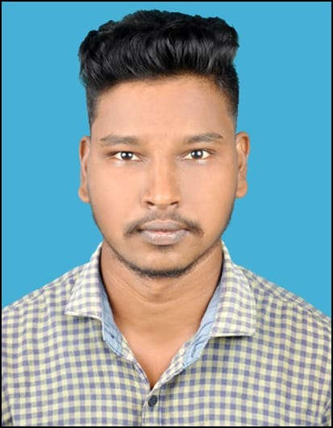
RESUME
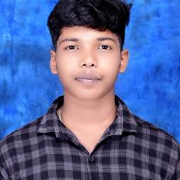
Career Objective

TAMILARASAN A

ELECTRICAL ENGINEER
✆ +91 8903187885
✉ atamilarasan444@gmail.com

PERSONAL DETAILS
DOB : 17/09/2003
Nationality : Indian Sex : Male
Martial Status : Single

LANGUAGES KNOWN
Tamil & English

ADDRESS

S/0 AYYANAR P
26, Mariyamman Kovil Street, B.Vadugapalayam,
Cuddalore-607004,
Tamilnadu.
Energetic EEE graduate seeking an entry-level role to apply theoretical knowledge in practical electrical systems and grow into a skilled professional in the power, transmission automation sector. Eager to apply strong technical knowledge and hands on experience to enhance system performance and safety standards in challenging environment.
Professional Details

1. Diploma in Electrical and Electronics Engineering
Passed in 2019 – 2022.
Vigneshwara Polytechnic College (Allapakkam).
2. Bachelor of Engineering in Electrical and Electronics Engineering Passed in 2022 – 2025.
Krishnasamy College of Engineering & Technology,
ANNA UNIVERSITY, TAMILNADU, INDIA.
Career Profile

- Organization : Delphi TVS, Sriperumbudur.
Designation : Production Engineer
Period : April 2025 to October 2025.
Internship

Participated in the Two Weeks Internship Training Program on “RENEWABLE ENERGY” in JULY 2024 at Krishnasamy College of Engineering and Technology, Cuddalore.
NAAN MUDHALVAN COURSE

  - “Design of Photo Voltaic System” Organized by L&T in Naan Mudhalvan.
  - “Microsoft office 365 specialist” in Naan Mudhalvan.
  - I have a completed a project in Naan Mudhalvan, as I designed a solar PV system to a commercial building with assumption load by using simulation software, whereas Reverse Engineering, Matlab, Sam ,PV System.
Skills
  - MATLAB
  - PV SYSTEM
  - SAM( System Advisory Model )
  - MS OFFICE
Declaration

I hereby declare that the information provided above is true and correct to the best of my knowledge and belief.

Yours faithfully, TAMILARASAN A

